“Data Transformation, Modeling & Visualization with Power BI”

Bike Station Performance & Availability Dashboard
1. Project Objective:
The objective of this project is to analyze bike station operations by monitoring availability, capacity, and utilization across different locations and contracts. Analyze bike station data to monitor availability, capacity, and utilization. The dashboard helps identify demand patterns, high-usage Bike.
2. Tools & Technologies:
- Power BI – Dashboard development and data visualization
- Power Query – Data cleaning and transformation
- DAX (Data Analysis Expressions) – KPI and measure creation
- Microsoft Excel – Data source
3. Data Modeling:
Implemented a star schema with Fact and Dimension tables. Created surrogate keys to ensure data integrity and efficient relationships.
4. Key KPIs:
• Total Available Bikes
• Total Available Bike Stands
• Total Capacity
• Utilization %
• Full & Empty Bike
5. Dashboard Features:
Interactive visuals including KPI cards, trend analysis, map visualization, and status distribution. Enabled filtering using slicers for station, date, and status.
6. Key Insights:
Identified peak usage hours, high-demand stations, and underutilized locations. Geospatial analysis helped understand regional performance.
7. Conclusion:
This project demonstrates strong skills in data cleaning, modeling, and visualization. The dashboard provides actionable insights for improving operational efficiency.

8. Dashboard :
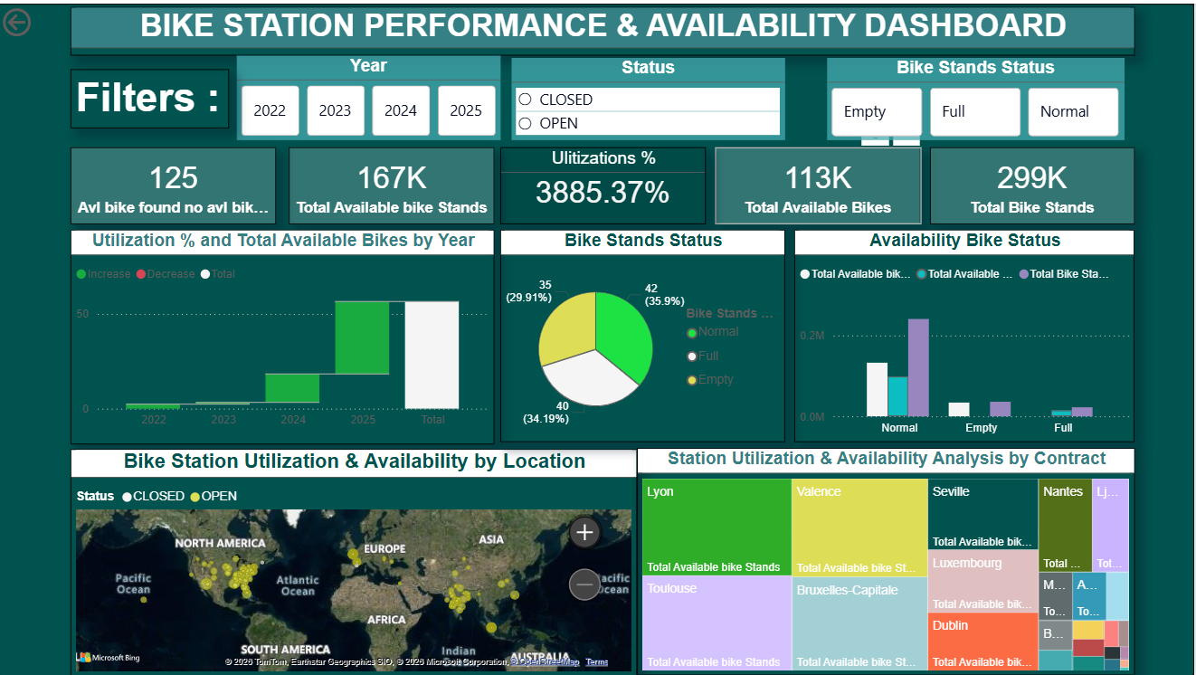
- Screenshot(s) of cleaning and transformation steps and visualization :
Fact table ( Fuiel):
- All Column Empty Rows Remove and Data Clean all Column (Trim & Clean)
- Number Cannot Remove Duplicate (Number Not Primary Key Same Number but Name and Address Different So Using Dimension Table Individual to Create and Key factor Set in Main table.
- Dim Date Month Year Date and Month Split and Merge for Main table.
Data Modeling :
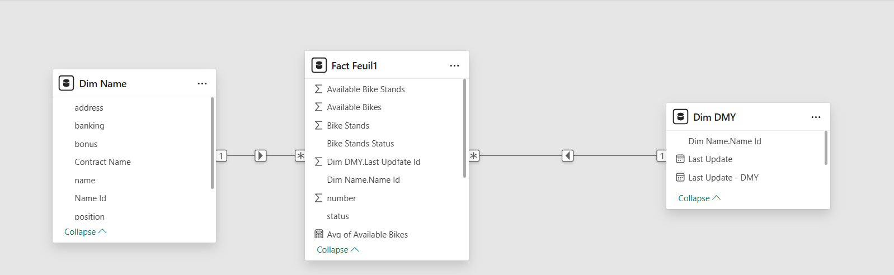
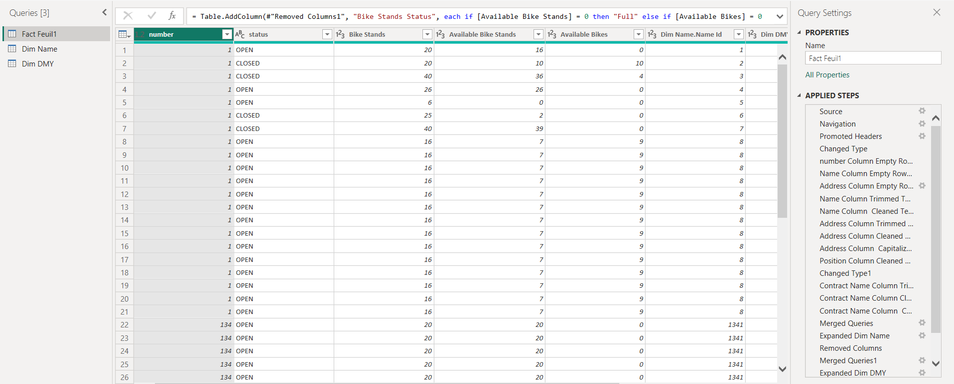
Dim DMY:
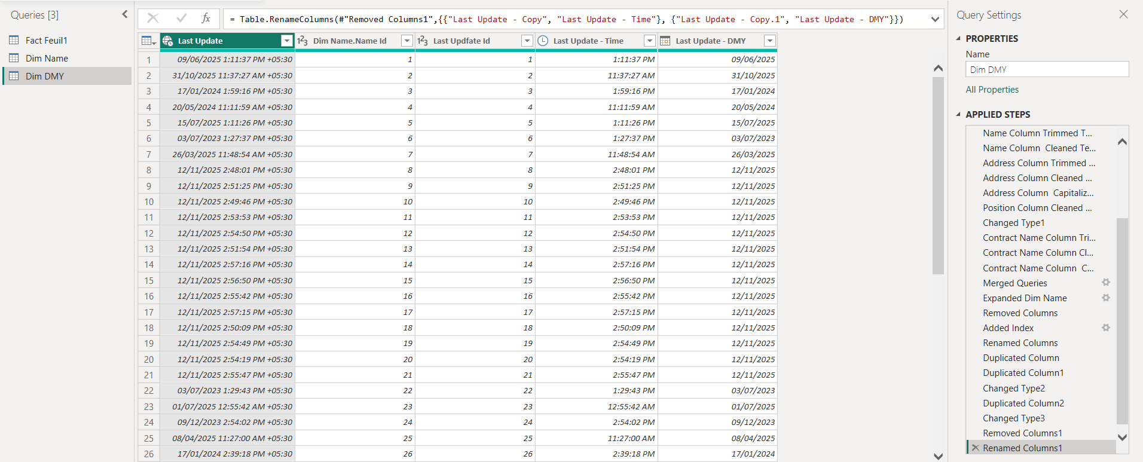
Dim Name :